# 3 Specific Requirements

## 3.1 User Interface

The website will feature a home page which contains a summary of all the features, a simple, interactive presentation of some featured cars, statistics, stocks and sales information.

It will also feature an “about us” page containing information about the site owners and a car listing page which will contain the database of all available cars, complete with detailed information about all of their features and prices, including current availability.

There will also be a FAQ page with frequently asked questions about the car rental services and a “contact us” page containing contact information. There may also be buttons which contain links to social media.

The user has the ability to log in and rent a car. There is a search bar which can easily find a specific car, or it can be selected from the car listing page. Users also have access to their personal profile where they can see the bookings they have made, and can be suggested cars similar to the ones they’ve booked.

Satisfied customers, a newsletter, and a special admin login button are also available.

The website should work and be tested against Microsoft Edge, Firefox, Google Chrome.\

A wireframe model of an early version has been attached.

Note: The top two horizontal bars in the first wireframe are the **header**.

The bottom horizontal bar containing the additional info, admin login and newsletter is the **footer**.

## 

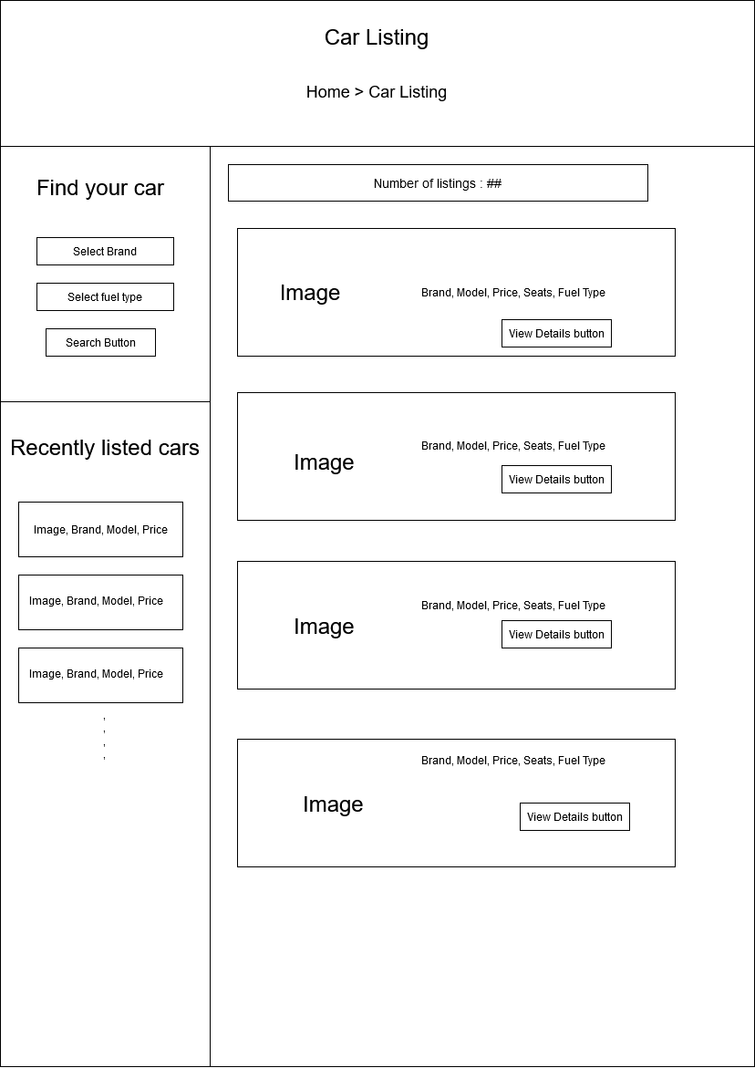

**3.2 Functional Requirements**

This section includes the requirements that specify all the fundamentalactions of the software system.

**3.2.1 User Class 1 – The User**

3.2.1.1 – A user should be able to acess th website through either a browser or similar service. The website should be free to access.

3.2.1.2 - When a new/updated version of the website is released, the user should check for these manually, however the newsletter will notify of the changes.

3.2.1.3 - Given that a user has accessed the website, then he should be able to register through the login/register service. The user must provide a name, password and e-mail address. A mobile phone number can also be introduced.

3.2.1.4 - Given that a user has registered, then the user should be able to log in to the web application. The log-in information will be stored on the browser and in the future the user can opt to be logged in automatically.

3.2.1.5 - Given that a user has registered, then the user should be able to retrieve his/her password by e-mail.

3.2.1.6 - Given that a user is logged in to the web application, then the first page that is shown should be the home page. The user should be able to search for a rental, according to several search options. The search options are Brand and Fuel type. There should also be a free-text search option. A user should be able to select multiple search options in one search.

3.2.1.7 - A user should be able to select a vehicle from the list. When a selection is made, user should be sent to the web application’s car booking page, where he can view more details about that certain vehicle. The user should then be prompted to fill in a form in order to book a car. When the booking is complete , a user should be able to go back to the search page on the web application.

3.2.1.8 – A user should be able to check their profile in order to view information about many facilities of the web application. A user should be able to update their information.

3.2.1.9 - Given that a user has accested their profile page, then the user should be able to view their bookings, and see whether they are confirmed, cancelled or pending.

3.2.1.10 - A user can post a testimonial for the administrator to see, and also view their past testimonials. This testimonial can be seen by the administrator.

3.2.1.11 – A user must be able to sign out and log in at any time. Registration process should prompt the user accordingly, depending on the requirement.

**3.2.2 User Class 2 – The Administrator**

3.2.2.1 –The administrator is the super-user who can manage everything on the website. Admin can log in through the special “Admin login” page found in the website footer.

3.2.2.2 – An administrator can create vehicle brands that are to appear on the web application, and can also manage them (edit, delete).

3.2.2.3 – An administrator shall be able to post a vehicle listing on the website, for every user to see and select for booking.

3.2.2.4 – An administrator can manage all bookings, in the sense that they can confirm or cancel the pending booking. This decision will be displayed on the respective user’s profile page.

3.2.2.5 – An administrator can manage testimonials, and set their status to be either active or inactive. The decision will be displayed on the respective user’s testimonial section in the profile page.

3.2.2.6 – An administrator can manage Contact us query, where users and guest users’ messages regarding their opinion and suggestions related to the website can be actively seen and read.

3.2.2.7 - Administrators can see the details of registered users, to ease the process in case any of them have problems to resolve regarding customer support.

3.2.2.8 - The administrator may update any publicly available details, such as the contact us details.

3.2.2.9 - An administrator can manage subscribers to newsletter, view their email address and remove any of them from the newsletter. The removal process is entirely at the administrator’s discrection.

3.2.2.10 – Administrators have access to the Admin dashboard, a statistics menu with values like the number of registered users, total bookings, total subscribers, total contact us queries, etc.

3.2.2.11 - An administrator is able to change his own account password inside the administrator panel.

3.2.2.12 - An administrator is able to log out of the administrator panel at any time.

**3.2.3 User Class 3 – The Guest**

3.2.3.1 – A guest can freely view the web application and check out the information about rental cars.

3.2.3.2 - A guest may not book a vehicle without registering and logging into their account. Anyone can register through the registration page.

3.2.3.3 – Guest users can also inquiry through the “Contact us” page.

3.2.3.4 - A guest user can become a logged-in user and vice versa, through the sign up, sign in/ sign out options.

3.2.3.5 – Guest type users may not interact with administrators.

3.2.3.6 - Guest users can subscribe to web application newsletter by entering an email, without having to log in.

3.2.3.7 – Guest users should be prompted to log in whenever performing an illegal action, such as booking a vehicle.

**3.3 Use Case Diagram**

